**CTF Topic: Cryptography Basics**



**1. Introduction**



Cryptography is the science of securing communication and information through codes. It involves encryption and decryption to protect data from unauthorized access. Understanding basic cryptographic methods is essential for both defenders and attackers. Defenders use cryptographic techniques to protect sensitive data, while attackers aim to break these codes to gain unauthorized access.

This Capture the Flag (CTF) scenario is designed to introduce beginners to cryptographic concepts and practices using simple, online-based tools.

**2. Tools and Requirements**

* Base64 Decode: Decode Base64 encoded strings.
* Hash Identifier: Identify the type of hash.

**3. Scenario**

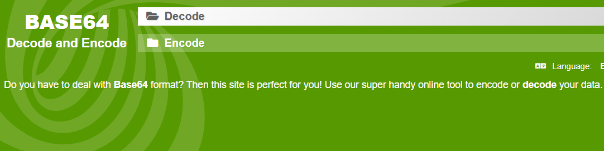

As a beginner cryptographer, your task is to solve various cryptographic challenges using online tools. You will decode messages, identify hashes, and encrypt/decrypt data to capture flags.

**Process**

Step 1: Go to Your Browser and open the link .

Step 2: Go to the <https://www.base64decode.org/> and paste the encoded message SGVsbG8gd29ybGQh and decode it.

Step 3: Go to the <https://hashes.com/en/tools/hash_identifier> and paste the has value

5d41402abc4b2a76b9719d911017c592 and identify that.

**Questions**

Flag 1: What is the decoded message?

Answer: Hello world!

Flag Captured.

Flag 2: What is the type of this hash?

Answer: MD5

Flag Captured.

Hint

For example, as mentioned in the question you should visit the online tool with the help of the link provided and do what is said. You can see flag 1 has been done for you.

